

C-Section Recovery Timeline
So you had a c-section? Congratulations on your bundle of joy!
Take a look at these helpful tips to feel better faster:
At the hospital:
- If you use an abdominal binder for comfort, place a pad (any soft cloth will do) between the binder and your skin to prevent rubbing.
- To help with scar pain, place an ice pack over 1-2 layers of clothing or towels (NOT directly on skin) and check the scar regularly while icing.
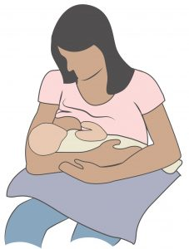
- Breastfeeding? Make sure to find a comfortable position for you! Here are some ideas to take pressure off your belly:
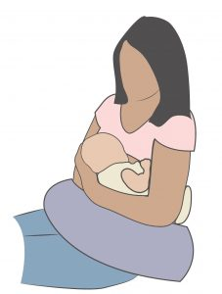
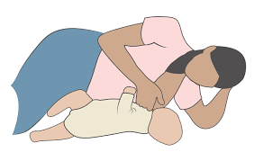
- Protect your belly by rolling to your side before sitting up. Sitting straight up might be painful and is not good for your healing muscles.
- Breathe out when getting out of bed or a chair, when picking up your baby, and especially when pooping! Holding your breath might feel easier, but puts a lot of pressure on your belly and pelvic area.
- Drink lots of water and consider a stool softener to help make that first poop more comfortable.
- Now is the time to relax and recover. However, walking, gentle kegels (pelvic floor squeezes) and abdominal pull-ins should be OK as long as you check it with your physician or PT first.

The First 6 Weeks (or until your check up with your doctor):
- Wait until cleared by your physician to have sex, exercise or start lifting anything heavier than your baby.
- When your scar fully heals (no staples/stitches, scabs, bleeding), you can start gently massaging for a couple minutes each day. Move your scar up and down, side to side or in circles.
- If you have any of these symptoms, or something feels “wrong”, call your physician. Do NOT wait until your next scheduled appointment.
    - Bleeding or oozing from your scar
    - Gaps or separation of the scar
    - A lot of swelling or pain in the belly or vagina
    - Spreading redness around the belly

After 6 weeks
- Take all the time you need to return to sex and exercise. Listen to your body. If you are not ready, know that you are not alone. Talk to your physician or PT for help!
- After 9 months of pregnancy, your pelvic floor muscles might need some help. Talk to your doctor or pelvic PT if you notice:
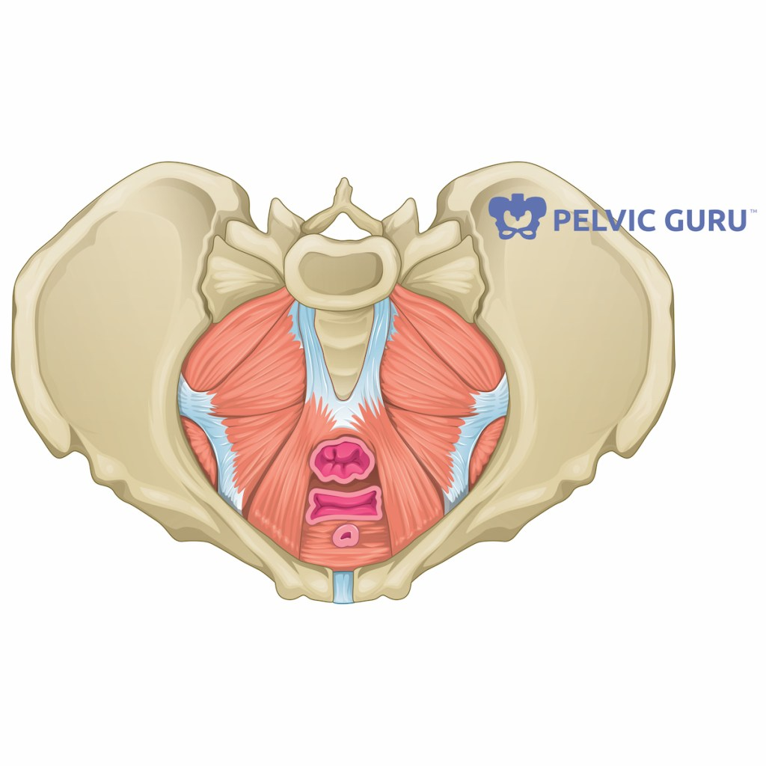
    - urinary incontinence
    - pelvic pain, heaviness or pressure
    - constipation or pain with bowel movements
    - pain during sex, pelvic exams or tampon use
    - anything feels “different” in the vagina or rectum
Permission to use copyright image from Pelvic Guru, LLC pelvicguru.com

- Does your belly feel weak or look different? The abdominal muscles might separate during pregnancy or c-section. This is called diastasis recti abdominis (DR or DRA), and can be helped by physical therapy.
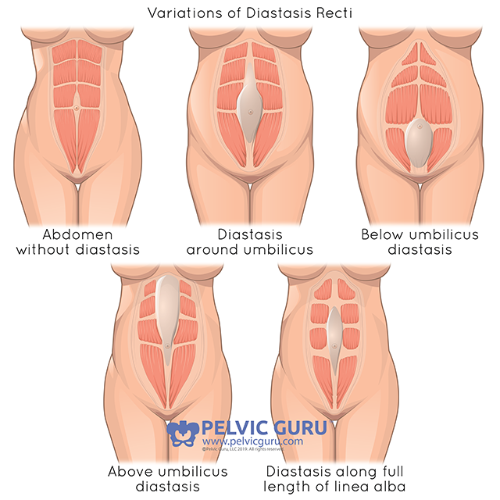

Permission to use copyright image from Pelvic Guru, LLC pelvicguru.com

- Once cleared by your physician, you can slowly get back to any exercise you want! Here are some tips:
      - Start small and build up as your body feels more comfortable.
      - Remember to breathe!! Your pelvic and abdominal muscles will work better.
      - Pain is a sign you might be pushing too hard.
      - If you are experiencing any symptoms, see a pelvic floor PT. We are happy to help you find the best exercises for you!

One last reminder: Your postpartum body is beautiful no matter how it has changed!

